Ndnd

1.Tick (✓) the correct answer. ( 3×1=3)
a.What is slow moving air?
i.Wind. ii. Breeze. iii.Storm
b.Which machine works with the help of the moving water?
i.Aeroplane. ii. Rocket. iii. Turbine
c.Which one is sinking object?
i.Metal coin. Ii. Leaf. iii.Paper boat
2.Write “T” for true and “F” for false statement.( 3×1=3)
a.Always cross the road through the zebra crossing.
b.Snowfall occurs in summer.
c.Sugar is soluble in water.
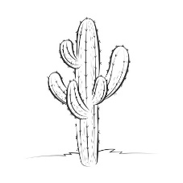
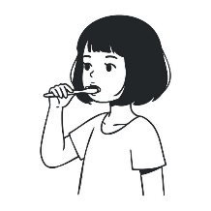
3.Identify the picture. (4×1=4)
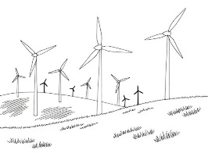
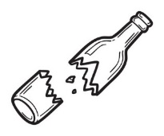

4.Match the following.(4×1=4)
a.Accident Twice a day
b.Brush Desert animal
c.Sunflower Flowering plant
d.Camel First aid
5.Answer these questions.(4×2=8)
a.What are the sources of food?
_________________________________________________________________________
b.What attracts mosquitoes and flies?
_________________________________________________________________________
c.How do you know that air is moving?
_________________________________________________________________________
d.Why should we not bite our nail?
_________________________________________________________________________
6.Draw a picture of a Lotus and colour it.(3)

